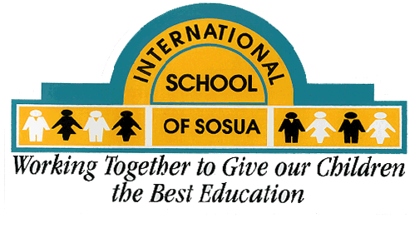
International School of Sosua
Course Syllabus- 2015-2016

Course Title: Middle School Physical
Education and Health
Instructor: Ms. Gaby Jiménez
E-mail: gaby.jimenez@issosua.com

Materials:
P.E.
ISS PE shirt or Hurricane Jersey

Dark loose fitting shorts or long dark yoga pants,
Socks + athletic shoes (no Crocs)
Yoga mat
Water bottle
Health
Notebook or section of a binder
Writing utensil
Device

Overview:
High School Physical Education and Health promises to teach students the importance of regular physical activity and the components of a healthy lifestyle. Students will have the opportunity to practice individual and team sports and will be encouraged to continue these practices their entire lifetime.
Objectives:
To improve individual fitness; specifically cardiovascular endurance, muscle strength and flexibility
To refine sport skills and strategies
To become a healthier and happier individual by using meditation, nutrition and physical activity
Outline/ Topics:
Fitness testing and Project
Basic sports, fundamentals: Soccer, basketball, Ultimate Frisbee, Handball, Net games
Health goals and implementation
Requirements:
Students are required to improve their fitness scores and demonstrate effort to accomplish health goals.
Students are required to participate in at least one after school sport or fitness club

Grading:
Standards
Respect
Effort
Responsibility
Policies and Expectations:
If students are absent on the day of fitness testing or skill tests, they are responsible to schedule another time with the PE teacher.
If the student has an excused absence, he or she is responsible to bring parent note to the teacher.
If the student can’t participate due to medical reasons, he or she is responsible for bring a doctor’s note to the teacher.
Procedure:
5 Minutes to change
15 Minutes health
60 minutes PE
5 Minutes to change
In case of an emergency: Parent or Guardian will be contacted immediately. We have a nurse on campus, but will call an ambulance if necessary.

Standards:
Standard 1 - The physically literate individual demonstrates competency in a variety of motor skills and movement patterns.
Standard 2 - The physically literate individual applies knowledge of concepts, principles, strategies and tactics related to movement and performance.
Standard 3 - The physically literate individual demonstrates the knowledge and skills to achieve and maintain a health-enhancing level of physical activity and fitness.
Standard 4 - The physically literate individual exhibits responsible personal and social behavior that respects self and others.
Standard 5 - The physically literate individual recognizes the value of physical activity for health, enjoyment, challenge, self-expression and/or social interaction.

