Theme  All About Me  Concepts  What do we know about ourselves?  What words do we know about begin with the letter “M”?  What is special to us?  What are your favorite foods?  Vocabulary  favorite, feel, self, me, friends, clothes, books, games, places  Phonics  Working with the phonetic alphabet in circle time (letters M,B) | Math  *Sorting by colors 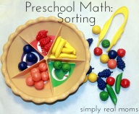  *Identifying number 1  *Matching fruit and naming them  *Exploring different objects with circle shapes  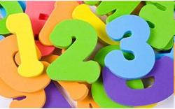
Activities  *Decorate your name different types of materials  *Bring a family picture. We will make a big poster of our family.  *Use a paper plate to create yourself  *Foot print painting  *Made a friends collage with different types of people from newspapers or magazines. | Books /Songs  *My Body  *Head, Shoulders, Knees and Toes  *Mama, Do You Love Me  *All About Me!!!  *Be my Friend!!  *David!!!  *If You’re Happy and You Know It

Please feel free to bring items or books to share about our themes.
Important Dates
Wednesday, September 3: Morning circle: by PreK-4, Please join us!!!
Wednesday, Sept 17: 12:00 Early Dismissal
Wednesday, September 24: No School

